**Virus types**

**Passive type:** these viruses are used to strengthen your attack viruses and are also used to weaken the systems defenses.

* ***Copy Cat***
* **Look:** Cheshire cat (think alice in wonderland) with tech googles and scanner tool.
* **Used for:** copying units into adjacent tiles
* **Cost:** 50 db, Limited by how many rows with fog of war removed.
* **Attack:** none
* **Special:**
* *Copy:* Scans and copies selected unit into an adjacent tile. Does not copy any add-on’s attached to the unit
* **Upgrade:**
* *Overload:* Creates 2 copies of selected unit

**Buffs/Helper type:** These will be used to either strengthen the performance of a virus on the playing field or help the game move forward.

* **Miner (helper)**
* ***Look:*** A small auger that drills into the playing field, periodically “unearthing” data (which appears in the form of small glowing orbs).
* ***Used for:*** Collecting data to spend on buying new viruses. This data is mined from the internet and is different from the data the player is trying to steal from the system.
* ***Cost:*** 1st one free. Each additional = 100 db
* ***Health:*** 0 immortal object
* ***Attack:*** None
* ***Movement:*** None
* ***Special:***
* *Mine –* gather data bytes at a rate of 5 a second, increasing by 1 every 10 seconds to a max of 50 a second.
* *Discover –* Unveils playing field at a rate of 1 row every 3 mins.
* ***Upgrades:***
* *Radar pack-* increase fog of war cleared by 1 row every 2 mins. (A rotating radar dish is added to the top of the drill platform)
* *Double Time –* increases base db mined by 5 db and max db a second to 100. (Animation speed of the drill increases as well)
* **Roid Ray Gun(Buff)**
* This is a single use item that you use on a virus. ( Example: PvZ Coffee bean wakes up normally nocturnal plants)
* ***Look:*** It looks like a cross between an inoculation gun and a future tech laser pistol. It has a vial at the base of the handle filled with a red chemical and a pressurized cartridge at the back of the barrel.

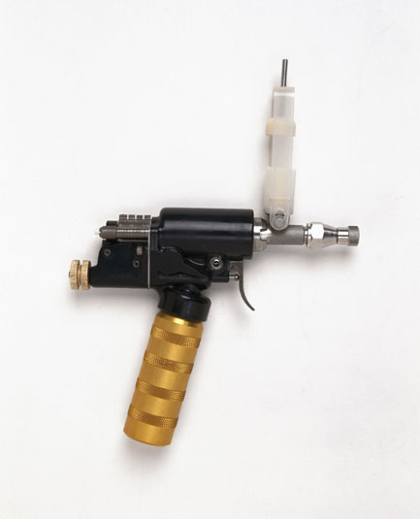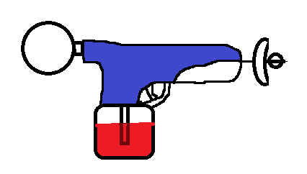

* ***Used for:*** buffing your attackers to make them stronger for a brief amount of time. (The effected virus gets a bonus to DMG,DEF, and increases in size for a short period).
* **Replicator/Root Kit**
* This is a single use item that you use on a virus. ( Example: PvZ Coffee bean wakes up normally nocturnal plants)
* ***Look:*** A transparent pod with an opening at the back that has an assembly line like conveyor belt from which the cloned virus is ejected. (The pod then disappears, the original virus is still in its place and you can now place the cloned virus as you please).

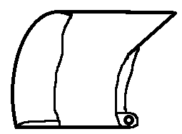

* ***Used for:*** duplicating the selected attacker making a new copy of it. This is a cheaper method of making attackers but has long timer.
* **Ghosting**
* ***Look:*** turns virus into a ghost of itself(Icon is a picture of a simple pac-man like white ghost. )



* ***Used for:*** Makes selected virus immune to defenses for short amount of time.
* **Overload**
* ***Look:*** Icon looks like a large battery with a voltmeter attached that is so far past max it’s broken the glass.
* ***Used for:*** making the attacker into a living bomb. On death, the virus explodes causing collateral damage to all nearby defenses. (Visual effect on virus- sparks flying off)
* **Over Clock**
* ***Look:*** Icon looks like an old wall clock, that’s on fire and melting.
* ***Used for:*** turns selected virus into a super speed version of itself. Virus can “blink/phase” past initial line of defense enabling it to attack behind it, with increased DEF.

**Attack type:** Theses are your bread and butter viruses. Their only goal is to attack.

* **Infestation Swarm**
* ***Look:*** swarm of little bugs (1’s and 0’s with pincers and wings)

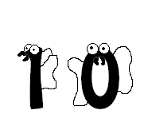

* ***Used for:*** Clouding the selected area from the defenses view (Does small DPS over a long time).
* **Muncher**
* ***Look:*** small spiky and fat. With a big mouth full of sharp teeth. (steven king langoliers)

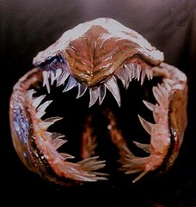

* ***Used for:*** slowly charges defenses then slowly eats away at it.
* **Spammer**
* ***Look:*** A Mini tank with a wide/skinny slotted barrel and a rectangular hopper at its rear.
* ***Used for:*** while slowly rolling forward it shoots Junk E-Mail and Documents long range and rapid fire at defenses.
* **Trojan(horse)**
* ***Look:*** Icon looks like a compressed file icon with a silhouette of a horse on it.



* ***Used for:*** Selecting two viruses to “compress”, and placing them both behind defenses to bypass initial defenses. (Newly uncompressed viruses get a limited time slight damage boost)
* **Splicer**
* ***Look:*** spider like machine with saw blades at the ends of its legs.
* ***Used for:***  Cutting away at the defenses fast. High DMG, low DEF.
* **Information Thief**
* ***Look:***Masked, hovering egg shaped machine equipped with a hose and a suction cup at the end. As the data orbs are stolen they can be seen as a bulge traveling through the hose. The more data the thief collects the larger its vacuum bag gets.

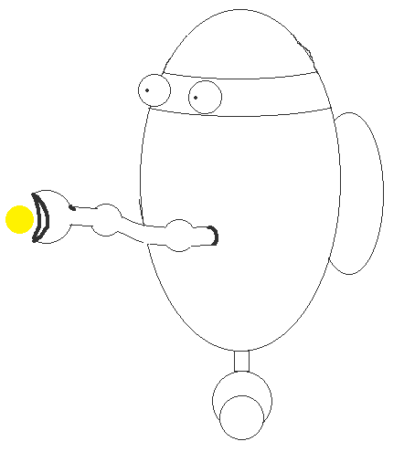

* ***Used for:*** stealing data from the system and bringing it back to base. The player needs to steal all of the systems data to win.
* ***Cost:*** *35db*
* **Health:** 25
* **Movement:** 1 tile a second
* **Attack:** none
* **Special:**
* *Steal:* hacks and steals all data in an information node. Takes 3 seconds to complete and destroys unit once completed.
* **Upgrade:**
* Dash: Increase movement speed to 2 tiles a second
* Stealth: Makes unit invisible and immune to damage for the first 3 seconds after creation.
* **Bug**
* ***Look:*** several different looking bugs
* ***Used for:*** basic attack type slowly walks to defenses and then attacks till destroyed.
* ***Cost:*** 25 db (should be spam able)
* ***Health:*** 10 db
* ***Movement:*** 1 tile every 2 seconds
* ***Attack:***
* Bite – attacks npc defense on tile in front of unit, 1 dmg a second.
* ***Special:***
* Infect – chews away fog of war on tiles moved to (clear only lasts while bug is alive).
* ***Upgrades:***
* Spit – spits poison forward when each tile is reached, adds 1 dmg every 5 sec when applied to npc (causes green hue on npc)
* **Bog Bomb**
* ***Look:*** Atom bomb with curse symbols on it. (think of the word bubbles on Qubert).

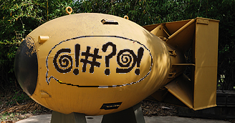

* ***Used for:*** Area attack that attacks a section of the grid confusing all defenses for a brief period of time. Also can be used to temporarily “extinguish” sections of the firewall to allow attackers behind enemy lines. (While the defense is in the confused state they will not attack and will have “Qubert” bubbles above them).
* **Parasite**
* ***Look:*** A tiny tick like insect that crawls up to and attaches itself to defender making it turn around and attack allies. As it fills up on data it gets slightly larger.
* ***Used for:*** turns the enemy defenses against the system. Only lasts for set amount of time. When the insect reaches its max data capacity (maybe 10) it detaches and heads back to the virus side.
* **Re-Director**
* ***Look:*** Metallic scaled skin with a projector that shines an image of a random virus onto selected misdirection section of the gird.
* ***Used for:*** redirects the attention of all defense within range (maybe a 3 *3 grid) near the immediate defender to a different area of the grid while the Re-Director is attacking. It is vulnerable while moving toward the defender and cannot be attacked by a defender that is being distracted its (maybe 3*3) grid. Low DEF, med ATK.
* **D Blocker/Meat shield**
* ***Look:*** Mini Tesla coil.
* ***Used for:*** Absorbing and blocking a selected defense from taking any action in a certain direction.
* ***Movement:*** None, stationary defense
* ***Cost:*** 35 db
* ***Attack:*** None.
* ***Health:*** Base health = 25, upgraded = 50
* ***Upgrades:***
* Health- +25
* Reflect- reflects 25% damage taken back at attacker